**WS14-EXAM INSPECTION**

**DATE: 02th december 2021**

**EXAM INSPECTION**

Solution, question 27

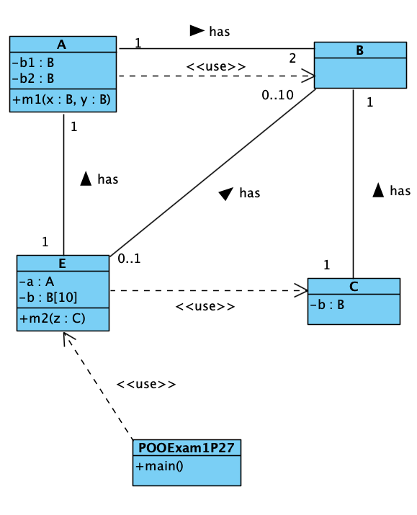

RUBIRC

1. A /1

2. B /1

3. C /1

4. E /1

5. POOExam1P27 /1

6. A-B assoc /1

7. A-E assoc /1

8. E-B assoc /1

9. E-C depend /1

10. C-B assoc /1

11. POOExam1P27-E (or any other class) depend /1

12. A-B depend /1

TOTAL /10

20 GUAMAN VEJARANO ANGEL DAVID

Inspector: Guitarra Jhon

1. A 1/1

2. B 1/1

3. C 1/1

4. E 1/1

5. POOExam1P27 0/1

6. A-B assoc 0.5/1

7. A-E assoc 0.5/1

8. E-B assoc 1/1

9. E-C depend 1/1

10. C-B assoc 1/1

11. POOExam1P27-E (or any other class) depend 1/1

12. A-B depend 1/1

TOTAL 10/10

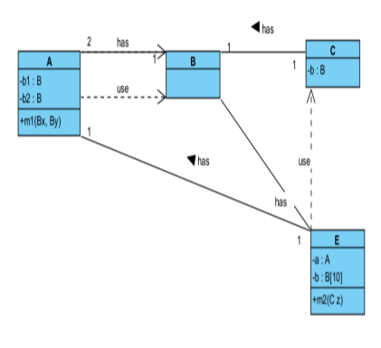

21 GUITARRA SANCHEZ JHON ALEXANDER

Inspector: Jose Guzman

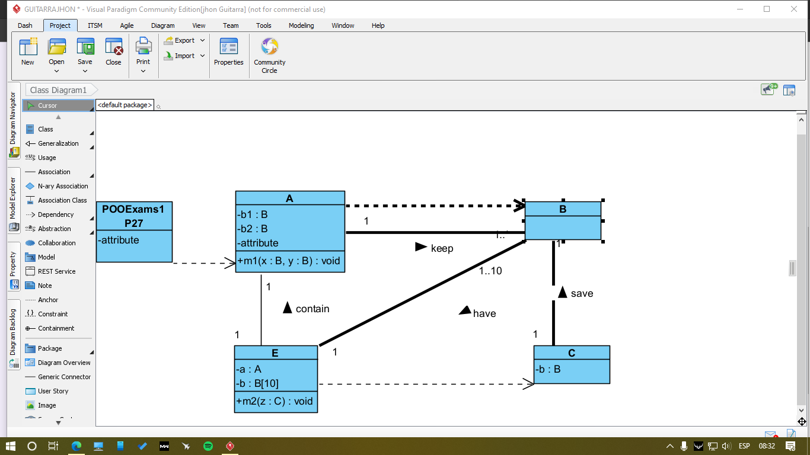

RUBIRC

1. A 1/1

2. B 1/1

3. C 1/1

4. E 1/1

5. POOExam1P27 0.5/1

6. A-B assoc 0/1

7. A-E assoc 1/1

8. E-B assoc 1/1

9. E-C depend 1/1

10. C-B assoc 0.5/1

11. POOExam1P27-E (or any other class) depend 1/10

12. A-B depend 1/1

TOTAL 10/10